Question 12

Configure a standard Access Control List (ACL) on a router to permit traffic from a specific IP range. Test connectivity to verify the ACL is working as intended.

Approach

Standard access-list will be in the range of 1-99 and 1300-1999. It filters traffic based only on the source IP address

Make the below given network

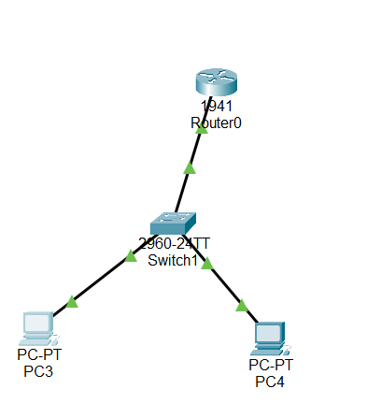

Now configure swith and create vlan’s

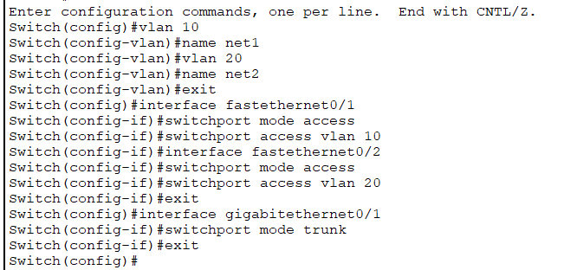

Now configure the router to communicate between inter vlan

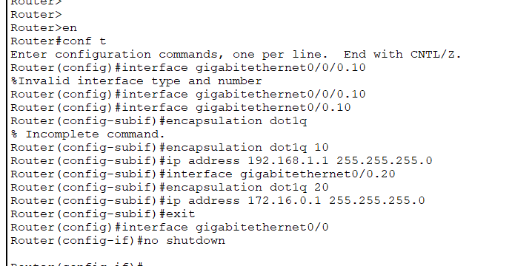

Now if you try to ping another network it works.

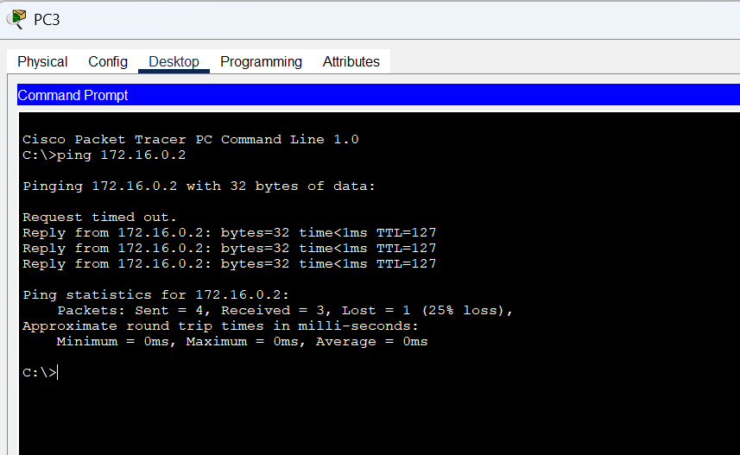

Now we are going to deny the packet from 192.168.1.2 using access-list

Configure the router with below command

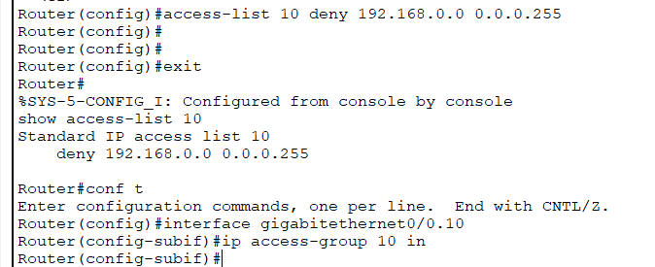

Now you can see the ping is unsuccessful

